Experiment 1
AIM:
TO study and apply network trouble shooting commands in live network environment

Objective:
To understand and demonstrate the use of various network troubleshooting commands (IPCONFIG, PING, ARP, TRACERT) in diagnosing and resolving common network issues in a live environment.

Materials Required:
- A computer with an active network connection (Windows, macOS, or Linux)
- Command-line interface (CLI) access (Command Prompt for Windows, Terminal for macOS/Linux)

Theory
Network troubleshooting commands are essential tools for diagnosing and resolving network connectivity issues. Each command serves a specific purpose:
- IPCONFIG: Displays the current network configuration details of a computer.
- PING: Tests the reachability of a host on an IP network and measures the round-trip time for messages.
- ARP (Address Resolution Protocol): Displays and modifies the ARP table used to map IP addresses to MAC addresses.
- TRACERT (Traceroute): Traces the path packets take to reach a network host, showing each hop along the way.

Procedure
IPCONFIG Command:
- Open the Command Prompt (Windows) or Terminal (macOS/Linux).
- Type ipconfig (or ifconfig on macOS/Linux) and press Enter.
- Observe the output which includes details such as IP address, subnet mask, and default gateway.
- Note: Use at least three options in this command and attach the screenshots under the title “example output”
PING Command:
- Type ping <hostname or IP address> and press Enter. For example, ping google.com.
- Observe the output which shows whether the destination is reachable and the time taken for each ping.
- Note: Use at least three options in this command and attach the screenshots under the title “ Output & Observation”
- Use CTR C keys to break the loop
ARP Command:
- Type arp -a and press Enter to display the ARP table.
- Observe the output which lists IP addresses and their corresponding MAC addresses.
- Note: To clear the ARP cache, use arp -d followed by the IP address on Windows.
TRACERT Command:
- Type tracert <hostname or IP address> on Windows or traceroute <hostname or IP address> on macOS/Linux and press Enter. For example, tracert google.com.
- Observe the output which shows each hop from your computer to the destination, including the round-trip time for each hop.
- Note: Use at least three options in this command and attach the screenshots under the title “output & observations”
- Use CTR C keys to break the loop

Output & Observations
- IPCONFIG: Provides detailed network configuration information.(vary the space for three different Screenshots)
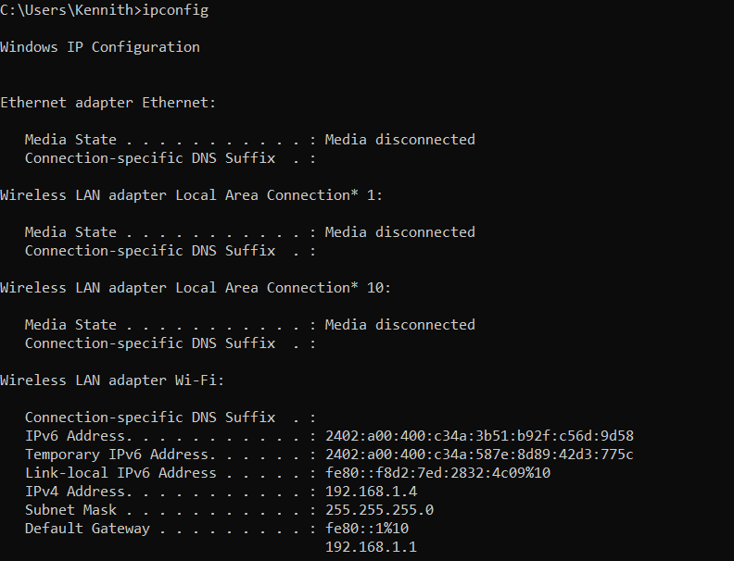

Ipconfig/all
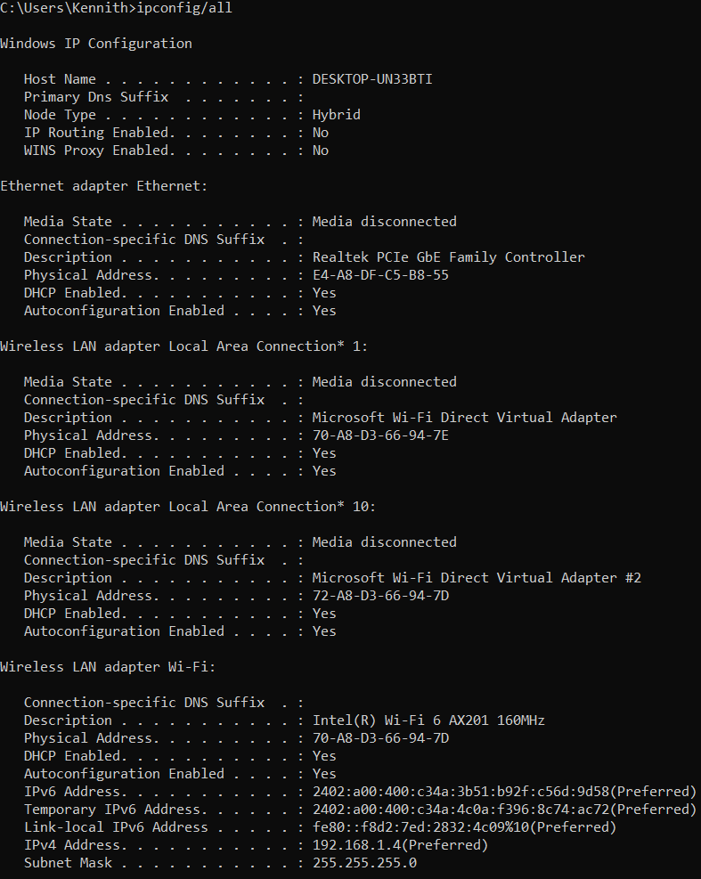
Ipconfig/flushdns
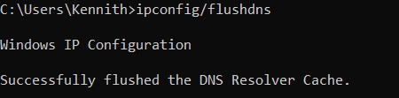
- PING: Confirms whether a host is reachable and measures the round-trip time.(vary the space for three different Screenshots)
ping www.google.com
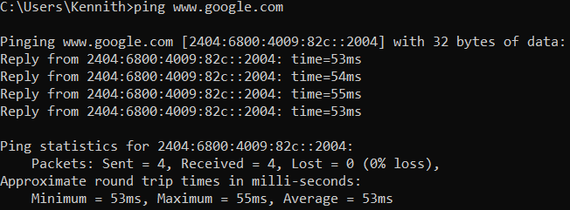
ping www.facebook.com
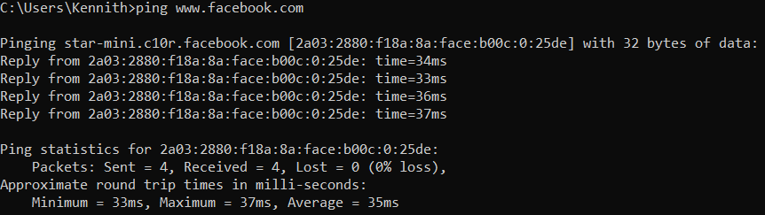
ping www.amazon.in
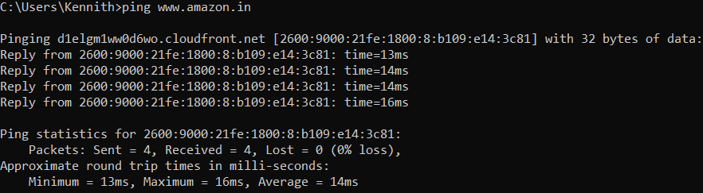
- ARP: Displays the mapping between IP addresses and MAC addresses.(vary the space forthree different Screenshots)
- Arp -a

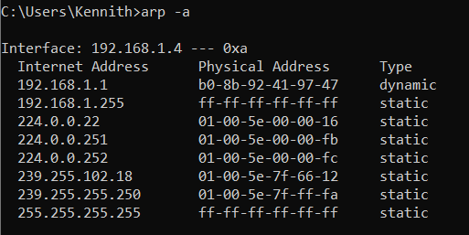

arp
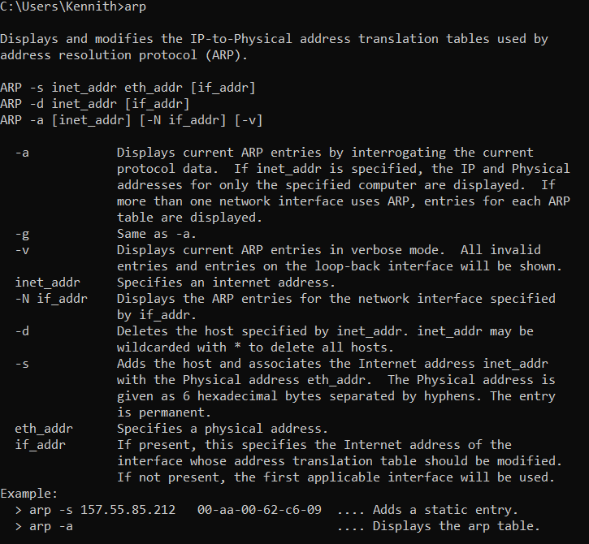
Arp -g
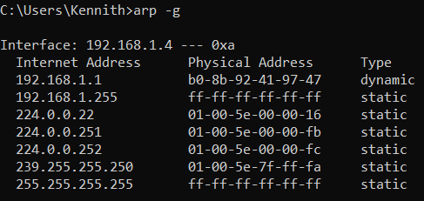
- TRACERT: Identifies the path packets take to reach a destination and where delays occur. (vary the space for three different Screenshots)

tracert www.google.com
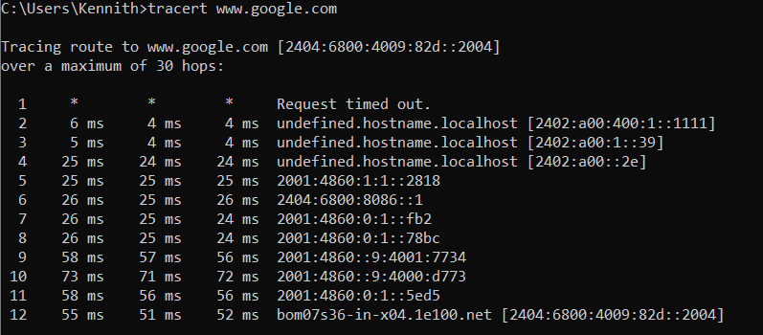
tracert www.facebook.com
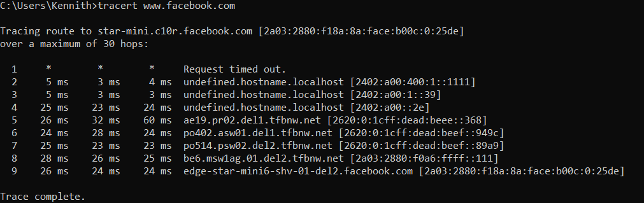
tracert www.google.com
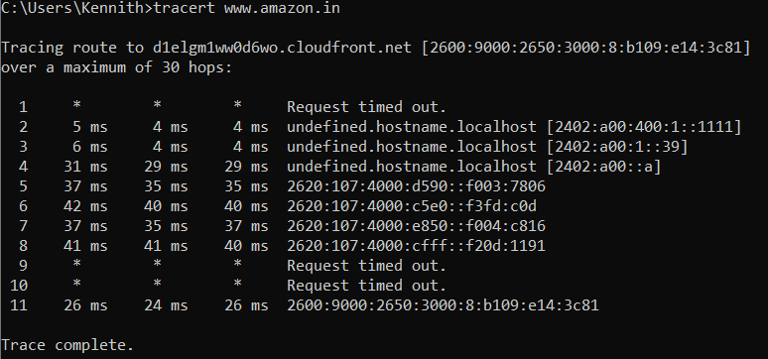

Conclusion
The experiment demonstrates the use of network troubleshooting commands to diagnose and resolve network issues. Understanding these commands is crucial for network administration and troubleshooting.

