Experiment: - 10
AIM: To Study MQTT protocol T

Objective: To measure Humidity, Temperature and control a LED through the internet via MQTT.
Theory:
MQTT is a Client Server publish/subscribe messaging transport protocol. This protocol is widely used in the field of IoT for communication between Machine to Machine because of its following features: light weight, open, and designed so as to be easy to implement.
This protocol is easy to implement and also very easy to understand. It basically comprises one Broker and multiple clients where clients can be treated as our smart phone, sensors, etc. and they all communicate with the server which is known as Broker.
In this protocol, every client needs to connect to any address of the broker which is known as the topic to be subscribed to in MQTT. In a single broker there can be multiple topics and clients can also subscribe to multiple topics of the same broker.

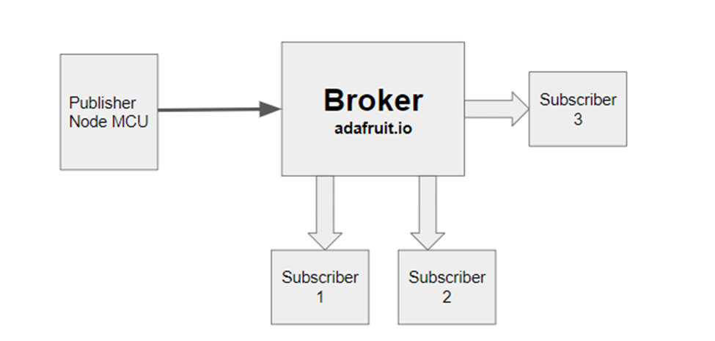
Figure 1: Example of MQTT protocol

Mobile Application Link:
https://play.google.com/store/apps/details?id=at.tripwire.mqtt.client&hl=en_IN

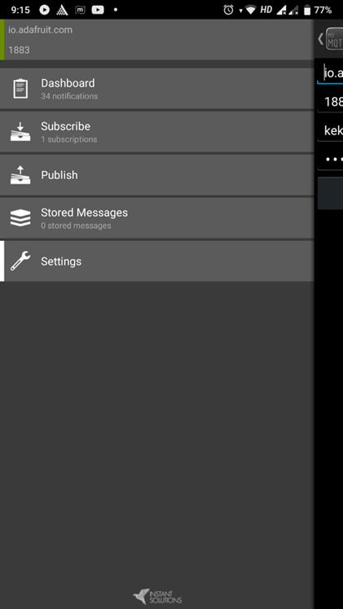 | 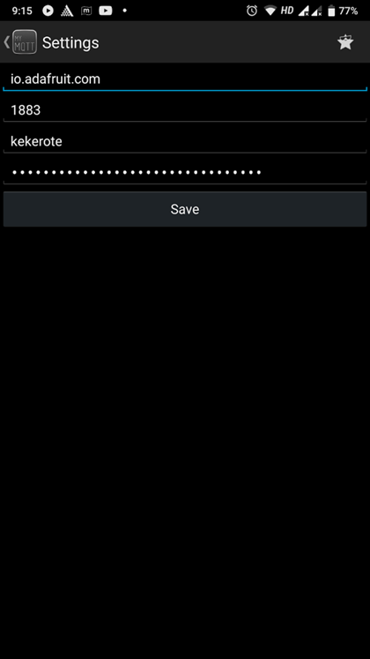
 | 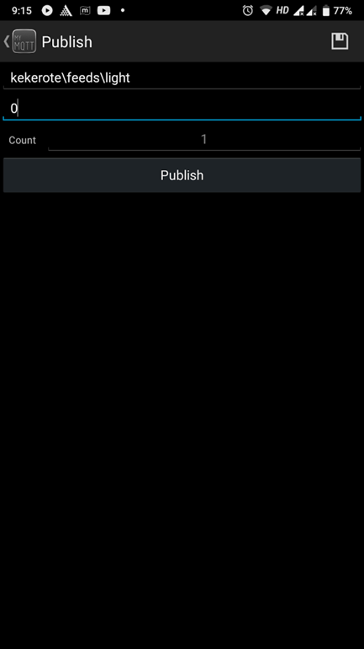
Figure 2: Mobile Application Settings
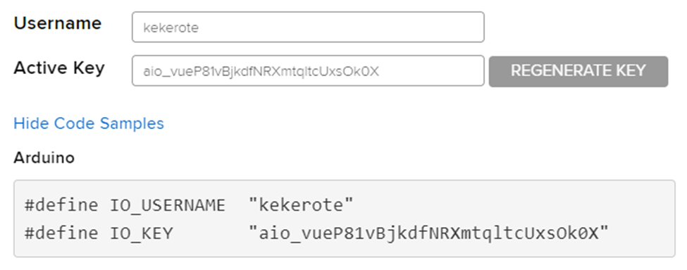
Figure 3: Adafruit.io platform user name and key
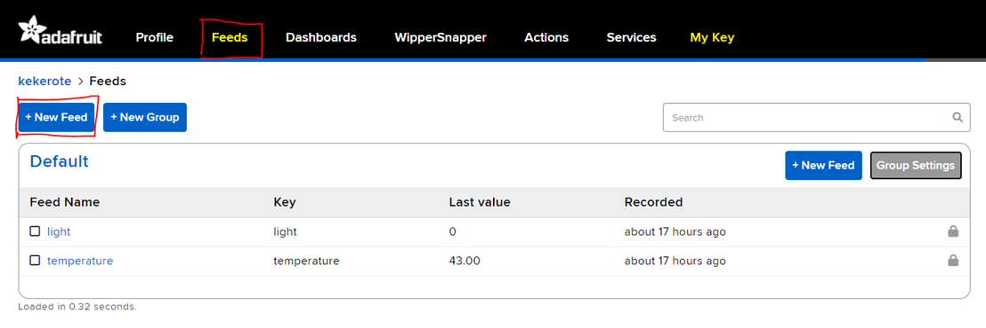
Figure 4: Feed Window
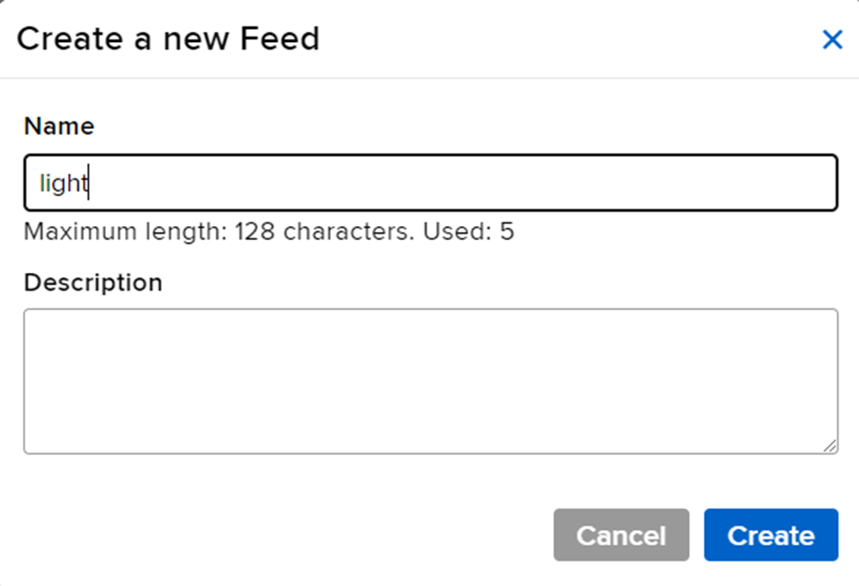
Figure 5: Creating a new feed
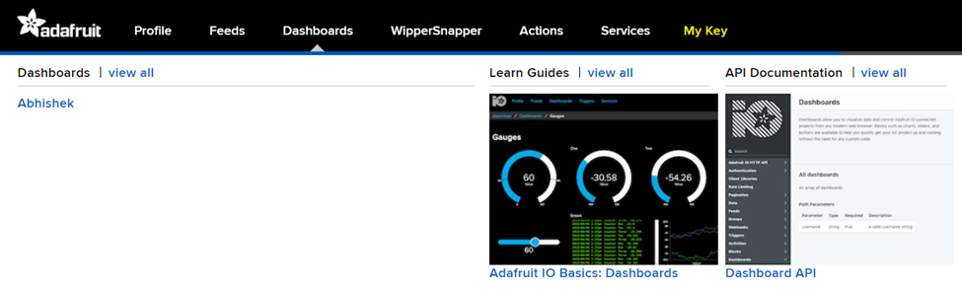
Figure 6: Dashboard Window
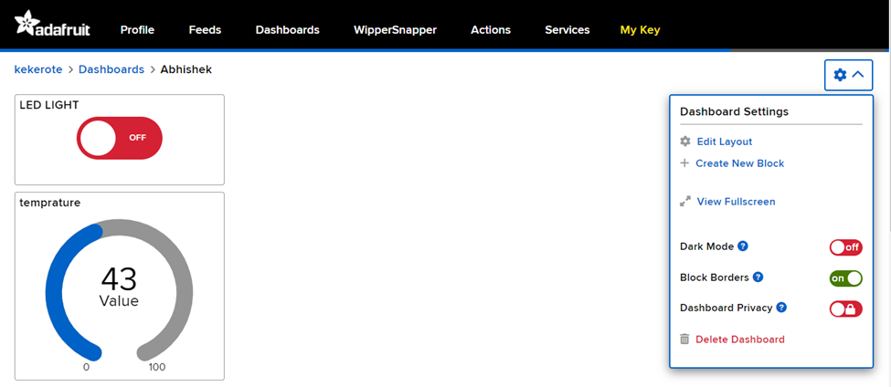
Figure 7: Dashboard Block
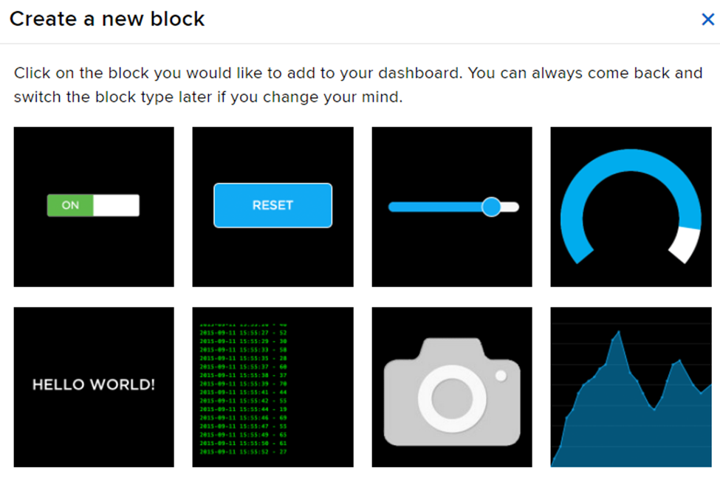
Figure 8: Creating a block in dashboard

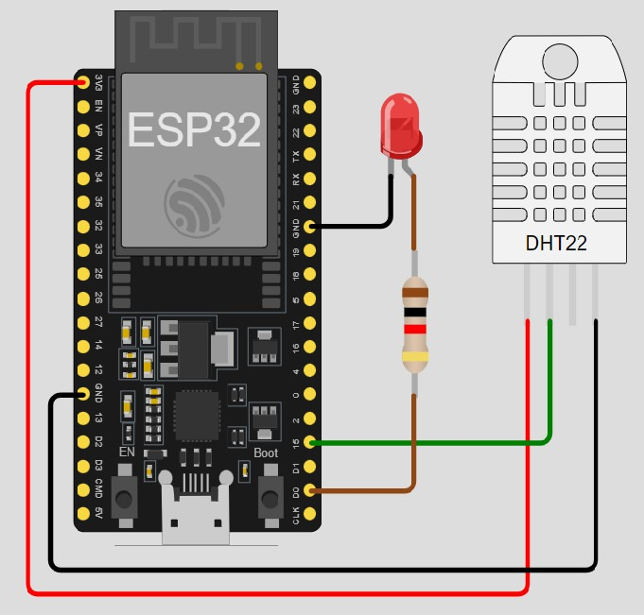
Connection Diagram:
Figure 9: Connection diagram
Program
#include <ESP8266WiFi.h>
#include "Adafruit_MQTT.h"
#include "Adafruit_MQTT_Client.h"
#include <Wire.h>
#include "DHT.h"
#define DHTTYPE DHT22

const int LED = 16;
uint8_t DHTPin = 5; //D1
DHT dht(DHTPin, DHTTYPE);
float _Temperature;
float _Humidity;
/************************* WiFi Access Point ***************************/

#define WLAN_SSID "Hare Krishn"
#define WLAN_PASS "Iot@1234"

/************************* Adafruit.io Setup ***************************/

#define AIO_SERVER "io.adafruit.com"
#define AIO_SERVERPORT 1883 // use 8883 for SSL
#define AIO_USERNAME "IOT_LAB_ADA"
#define AIO_KEY "aio_dAEH39JkzHCdypNLK3ZLgNPw4lGp"

/************ Global State (you don't need to change this!) *****************/

// Create an ESP8266 WiFiClient class to connect to the MQTT server.
WiFiClient client;
// or... use WiFiFlientSecure for SSL
//WiFiClientSecure client;

// Setup the MQTT client class by passing in the WiFi client and MQTT server and login details.
Adafruit_MQTT_Client mqtt( & client, AIO_SERVER, AIO_SERVERPORT, AIO_USERNAME, AIO_KEY);

/****************************** Feeds *******************************/

// Setup a feed called 'onoff' for subscribing to changes.
Adafruit_MQTT_Subscribe LIGHT = Adafruit_MQTT_Subscribe( & mqtt, AIO_USERNAME "/feeds/LIGHT");
Adafruit_MQTT_Publish Humidity = Adafruit_MQTT_Publish( & mqtt, AIO_USERNAME "/feeds/Humidity");
Adafruit_MQTT_Publish Temperature = Adafruit_MQTT_Publish( & mqtt, AIO_USERNAME "/feeds/Temperature");

/*************************** Sketch Code ******************************/

// Bug workaround for Arduino 1.6.6, it seems to need a function declaration
// for some reason (only affects ESP8266, likely an arduino-builder bug).

void MQTT_connect();

void setup() {
Serial.begin(115200);
delay(10);
pinMode(LED, OUTPUT);
pinMode(DHTPin, INPUT);
dht.begin();
Serial.println(F("Adafruit MQTT demo"));

// Connect to WiFi access point.
Serial.println();
Serial.println();
Serial.print("Connecting to ");
Serial.println(WLAN_SSID);

WiFi.begin(WLAN_SSID, WLAN_PASS);
while (WiFi.status() != WL_CONNECTED) {
delay(500);
Serial.print(".");
}
Serial.println();

Serial.println("WiFi connected");
// Serial.println("IP address: "); Serial.println(WiFi.localIP());

// Setup MQTT subscription for onoff feed.
mqtt.subscribe( & LIGHT);
}
void loop() {
// Ensure the connection to the MQTT server is alive (this will make the first
// connection and automatically reconnect when disconnected). See the MQTT_connect
// function definition further below.
MQTT_connect();

// this is our 'wait for incoming subscription packets' busy subloop
// try to spend your time here

Adafruit_MQTT_Subscribe * subscription;
while ((subscription = mqtt.readSubscription(5000))) {
if (subscription == & LIGHT) {
Serial.print(F("Got_light: "));
Serial.println((char * ) LIGHT.lastread);
uint16_t num = atoi((char * ) LIGHT.lastread);
digitalWrite(LED, num);
}
}
Serial.print(F("\nSending Humidity and Temperature value value "));
_Humidity = dht.readHumidity();
// Read temperature as Celsius (the default)
_Temperature = dht.readTemperature();
// Read temperature as Fahrenheit (isFahrenheit = true)
// Check if any reads failed and exit early (to try again).
if (isnan(_Humidity) || isnan(_Temperature)) {
Serial.println(F("Failed to read from DHT sensor!"));
return;
}
Serial.print(F("Humidity: "));
Serial.println(_Humidity);
Serial.print(F("% Temperature: "));
Serial.print(_Temperature);
Serial.println(F(" °C "));
if (!Humidity.publish(_Humidity)) {
Serial.println(F("Failed"));
}
delay(100);
if (!Temperature.publish(_Temperature)) {
Serial.println(F("Failed"));
}
delay(100);
}

// Function to connect and reconnect as necessary to the MQTT server.
// Should be called in the loop function and it will take care if connecting.
void MQTT_connect() {
int8_t ret;

// Stop if already connected.
if (mqtt.connected()) {
return;
}

Serial.print("Connecting to MQTT... ");

uint8_t retries = 3;
while ((ret = mqtt.connect()) != 0) { // connect will return 0 for connected
Serial.println(mqtt.connectErrorString(ret));
Serial.println("Retrying MQTT connection in 5 seconds...");
mqtt.disconnect();
delay(5000); // wait 5 seconds
retries--;
if (retries == 0) {
// basically die and wait for WDT to reset me
while (1);
}
}
Serial.println("MQTT Connected!");
}
Code Description:
ESP8266 with MQTT for Sensor Data and LED Control
This code connects an ESP8266 device to the internet via WiFi and uses MQTT (Message Queuing Telemetry Transport) to:
Measure temperature and humidity: It uses a DHT22 sensor connected to pin 5 and reads values using the Adafruit_MQTT library.
Control an LED: The LED is connected to pin 16 and can be turned on/off based on messages received over MQTT.
Publish sensor data: It publishes temperature and humidity readings to MQTT topics named "Humidity" and "Temperature" under the user's Adafruit.io account.
Subscribe to LED control: It subscribes to an MQTT topic named "LIGHT" to receive commands for turning the LED on/off.

Conclusion: We have studied and understood MQTT protocol by successfully performing the experiment of measuring temperature and humidity and controlling an LED via the internet using MQTT.

