Experiment 5
AIM:
To study basic router configuration using packet tracer

Objective:
To create, understand and demonstrate router configuration by using packet tracer

Materials Required:
- A computer with an active network connection (Windows, macOS, or Linux)
- Packet tracer software application installed

Procedure, Output and Observations
Router configuration:
- Click on Network devices, click on routers, select the 1841 router and place it
- Click on end devices, select the pc and place it
- Click on the router, in the physical tab, turn off the router, then there will be a WIC-2T serial connector, drag it to any one of the slots and turn on the router as shown
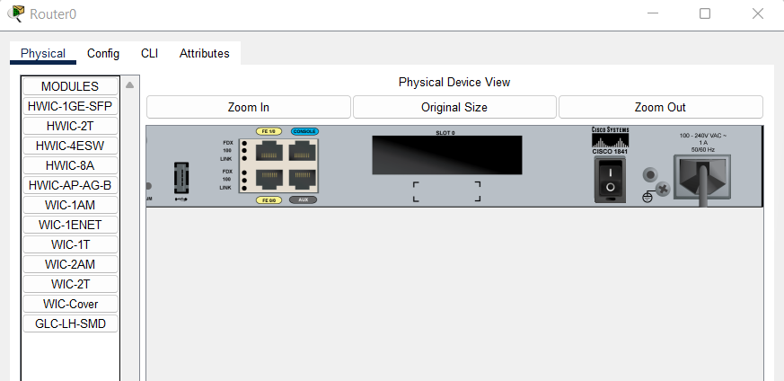
- Click on switch to turn off (green light will turn off)
- Drag the connector as shown
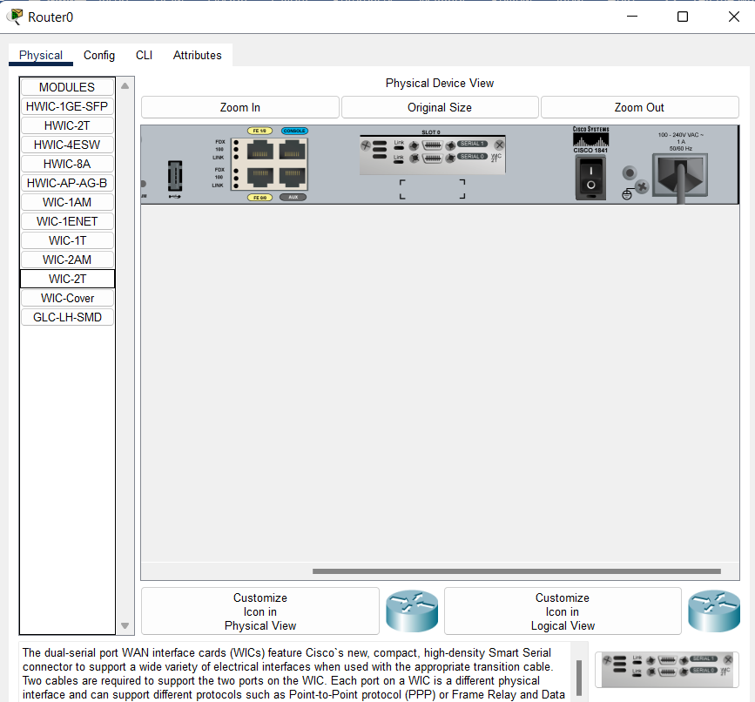
- Click on the switch to turn on the router, and it should look like this
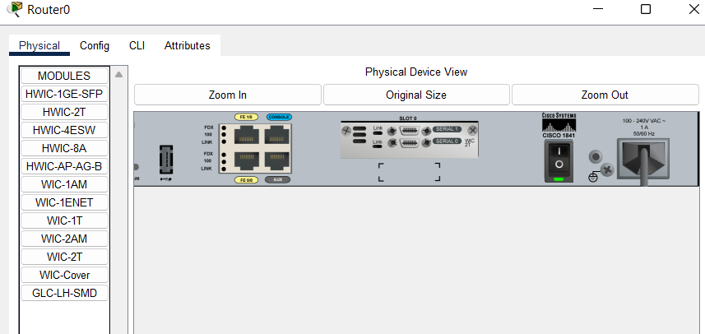
- Click on CLI tab and type no for the prompt (Would you like to enter the initial configuration dialog)
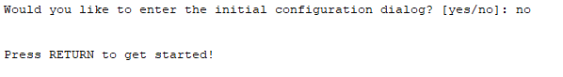
- Press return and Type “show ?” to check list of all commands
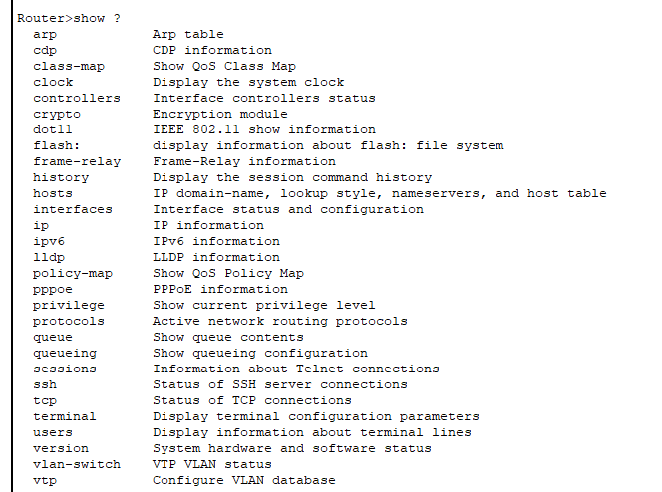
- Type “show version” to check version
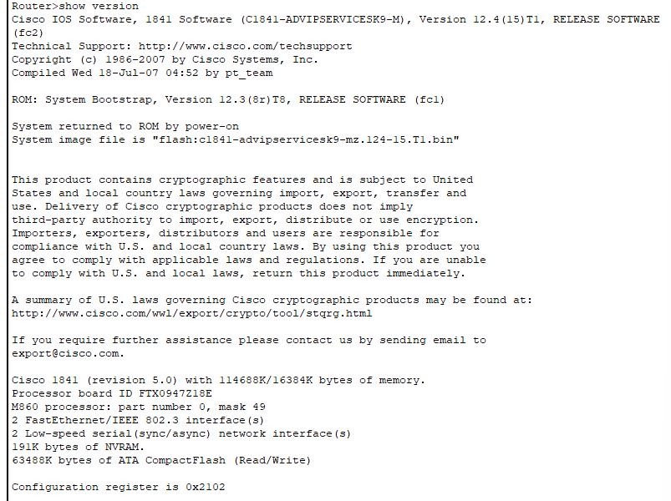
- The router has 3 modes 1)User mode 2)privilege mode 3)global configuration mode. By default we are in user mode(“>” in front of router indicates user mode), to switch to privilege mode type “enable”. It will show a Hash in front of the router in CLI
- Click on connections select the console wire and connect console of router with RS 232 of PC.
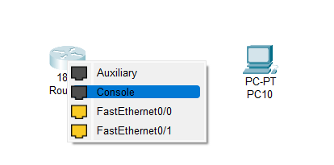
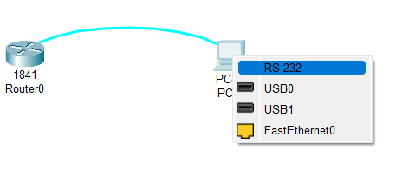

- Click on PC, go to desktop, open terminal and your settings should look like this
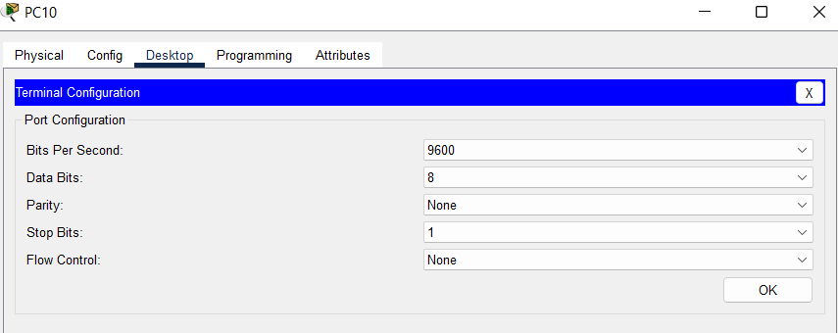
- Now click on router and go to CLI tab, type “config t” to enter global configuration mode. It should show config in front of the router.
- Type “hostname Indus” to change the name of the router as shown
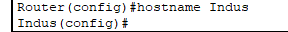
- Type “banner motd #Do not enter without permission#” to create and display the message before login.
- Hover on the router to note its fastEthernet number and serial number like this (we will be using it later).
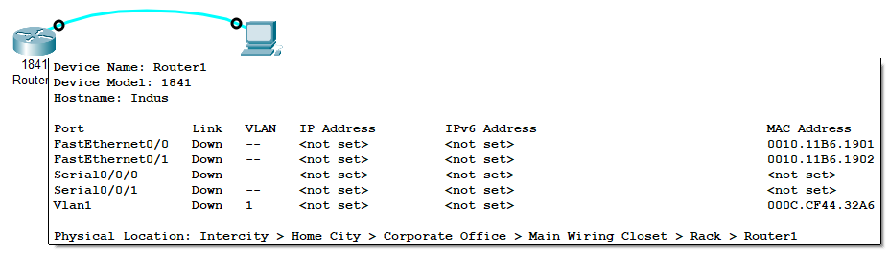
- Go to router’s CLI again and type “interface FastEthernet0/0” to configure that interface.
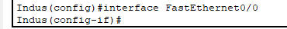
- Type the following:
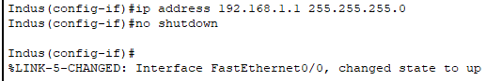
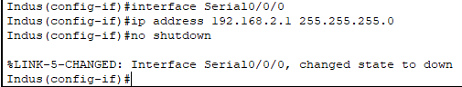
- We have interfaced the router, now we will move towards security configuration. Type “exit” to get out of interface.
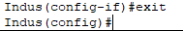
- Type the following to setup password for setting password for user mode.
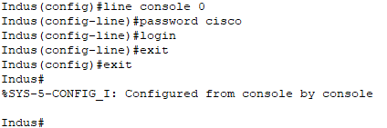
- Now type exit again. It wil take you to the message that we set up earlier and password which we also set up earlier.
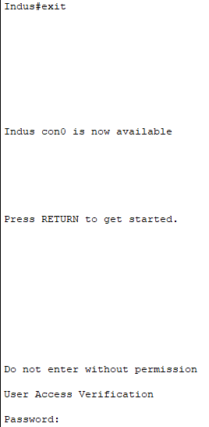
- Enter the password cisco (the typed password will not be visible when you type it). It should allow you to access user mode.
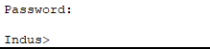
- Now enter the configuration mode again and type “enable secret cisco1”
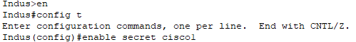
- Exit 2 times to get out of user mode.
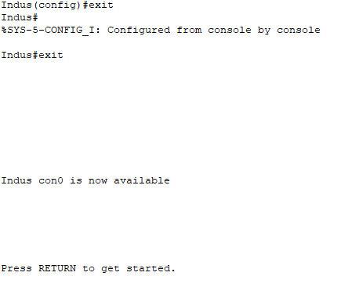
- When pressing enter it will ask for password to user mode which is “cisco”. Then we type en (short for enable) to enter privilege mode. This will again ask for password which is “cisco1”.
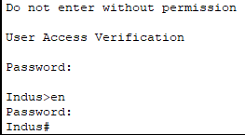
- We will enter configuration mode and type “line vty 0 4” and set up password “class” then type login and exit 2 times again.
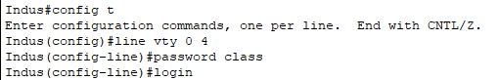
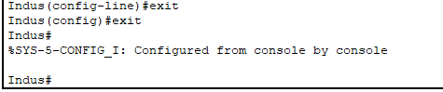
- To save the changes to memory type “wr” (short for write)
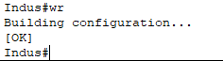
- Type “show running-config” to see all configurations
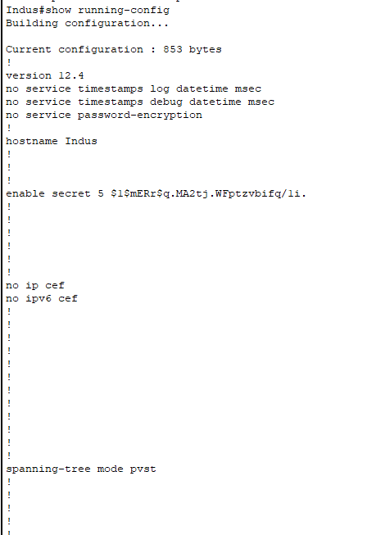
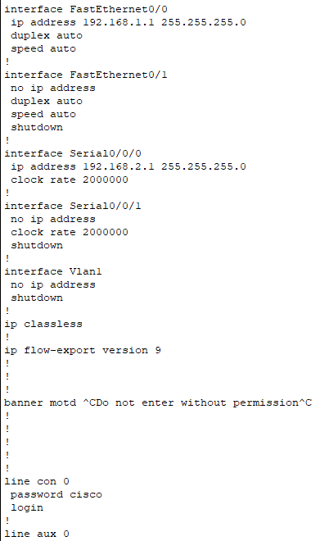
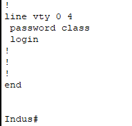
- Conclusion: The experiment demonstrates basic router configuration between a router and a PC. Understanding the configuration is crucial for network administration and troubleshooting.

