Experiment 6
AIM:
To study and design IP addressing for IPv4

Objective:
Use VLSM subnetting and subnetting to design ip addresses for a company with branches in ahmedabad, delhi and chennai. ahmedabad has 3 sub branches with A-120PCs, B-170PCs, C-60PCs. Delhi has 2 sub branches A-29PCs, B-14PCs. Chennai has 3 sub branches A-14PCs, B-6PCs, C-4PCs. Use class c private address with minimum wastage.

Materials Required:
- A computer with an active network connection (Windows, macOS, or Linux)
- Packet tracer software application installed

Procedure, Output and Observations
1. Calculate the Required Subnet Sizes
Ahmedabad Branches:
- Branch B: 170 PCs → /24 (256 IP addresses)
- Branch A: 120 PCs → /25 (128 IP addresses)
- Branch C: 60 PCs → /26 (64 IP addresses)
Delhi Branches:
- Branch A: 29 PCs → /27 (32 IP addresses)
- Branch B: 14 PCs → /28 (16 IP addresses)
Chennai Branches:
- Branch A: 14 PCs → /28 (16 IP addresses)
- Branch B: 6 PCs → /29 (8 IP addresses)
- Branch C: 4 PCs → /29 (8 IP addresses)
Ahmedabad to Delhi :
- Network → /30 (4 IP addresses)
Ahmedabad to Chennai :
- Network → /30 (4 IP addresses)
Delhi to Chennai :
- Network → /30 (4 IP addresses)
2. Allocate IP Subnets in a Continuous Manner
Ahmedabad Branch
- Branch B (256 IPs)
  - Network Address: 192.168.0.0/24
  - Usable IP Range: 192.168.0.1 to 192.168.0.254
  - Broadcast Address: 192.168.0.255
  - Subnet Mask:255.255.255.0
- Branch A (128 IPs)
  - Network Address: 192.168.1.0/25
  - Usable IP Range: 192.168.1.1 to 192.168.1.126
  - Broadcast Address: 192.168.1.127
  - Subnet Mask:255.255.255.128
- Branch C (64 IPs)
  - Network Address: 192.168.1.128/26
  - Usable IP Range: 192.168.1.129 to 192.168.1.190
  - Broadcast Address: 192.168.1.191
  - Subnet Mask:255.255.255.192
Delhi Branch
- Branch A (32 IPs)
  - Network Address: 192.168.1.192/27
  - Usable IP Range: 192.168.1.193 to 192.168.1.222
  - Broadcast Address: 192.168.1.223
  - Subnet Mask:255.255.255.224
- Branch B (16 IPs)
  - Network Address: 192.168.1.224/28
  - Usable IP Range: 192.168.1.225 to 192.168.1.238
  - Broadcast Address: 192.168.1.239
  - Subnet Mask:255.255.255.240
Chennai Branch
- Branch A (16 IPs)
  - Network Address: 192.168.1.240/28
  - Usable IP Range: 192.168.1.241 to 192.168.1.254
  - Broadcast Address: 192.168.1.255
  - Subnet Mask:255.255.255.240
- Branch B (8 IPs)
  - Network Address: 192.168.2.0/29
  - Usable IP Range: 192.168.2.1 to 192.168.2.6
  - Broadcast Address: 192.168.2.7
  - Subnet Mask:255.255.255.248
- Branch C (8 IPs)
  - Network Address: 192.168.2.8/29
  - Usable IP Range: 192.168.2.9 to 192.168.2.14
  - Broadcast Address: 192.168.2.15
  - Subnet Mask:255.255.255.248
- Ahmedabad to Delhi (4 Ips)
  - Network Address: 192.168.2.24/30
  - Usable IP Range: 192.168.2.25 to 192.168.2.26
  - Broadcast Address: 192.168.2.27
  - Subnet Mask:255.255.255.252

- Ahmedabad to Chennai (4 Ips)
  - Network Address: 192.168.2.28/30
  - Usable IP Range: 192.168.2.29 to 192.168.2.30
  - Broadcast Address: 192.168.2.31
  - Subnet Mask:255.255.255.252

- Chennai to Delhi (4 Ips)
  - Network Address: 192.168.2.32/30
  - Usable IP Range: 192.168.2.33 to 192.168.2.35
  - Broadcast Address: 192.168.2.35
  - Subnet Mask:255.255.255.252

 | Network ID | Broadcast ID | Host Range | Subnet Mask
Ahmedabad-B | 192.168.0.0/24 | 192.168.0.255/24 | 192.168.0.1/24 to 192.168.0.254/24 | 255.255.255.0
Ahmedabad-A | 192.168.1.0/25 | 192.168.1.127/25 | 192.168.1.1/25 to 192.168.1.126/25 | 255.255.255.128
Ahmedabad-C | 192.168.1.128/26 | 192.168.1.191/26 | 192.168.1.129/26 to 192.168.1.190/26 | 255.255.255.192
Delhi-A | 192.168.1.192/27 | 192.168.1.223/27 | 192.168.1.193/27 to 192.168.1.222/27 | 255.255.255.224
Delhi-B | 192.168.1.224/28 | 192.168.1.239/28 | 192.168.1.225/28 to 192.168.1.238/28 | 255.255.255.240
Chennai-A | 192.168.1.240/28 | 192.168.1.255/28 | 192.168.1.241/28 to 192.168.1.254/28 | 255.255.255.240
Chennai-B | 192.168.2.0/29 | 192.168.2.7/29 | 192.168.2.1/29 to 192.168.2.6/29 | 255.255.255.248
Chennai-C | 192.168.2.8/29 | 192.168.2.15/29 | 192.168.2.9/29 to 192.168.2.14/29 | 255.255.255.248
Ahmedabad-Delhi | 192.168.2.24/30 | 192.168.2.27/30 | 192.168.2.25/30 to 192.168.2.26/30 | 255.255.255.252
Ahmedabad-Chennai | 192.168.2.28/30 | 192.168.2.31/30 | 192.168.2.29/30 to 192.168.2.30/30 | 255.255.255.252
Chennai-Delhi | 192.168.2.32/30 | 192.168.2.35/30 | 192.168.2.31/30 to 192.168.2.34/30 | 255.255.255.252

PERFORMING IN CISCO PACKET TRACER
- Take 3 routers and add WIC-2T and NM-2FE2W modules in the router
- Name the routers as Ahm,Dlh and Chn. Also set the hostnames
- Connect the routers with serial DCE connection
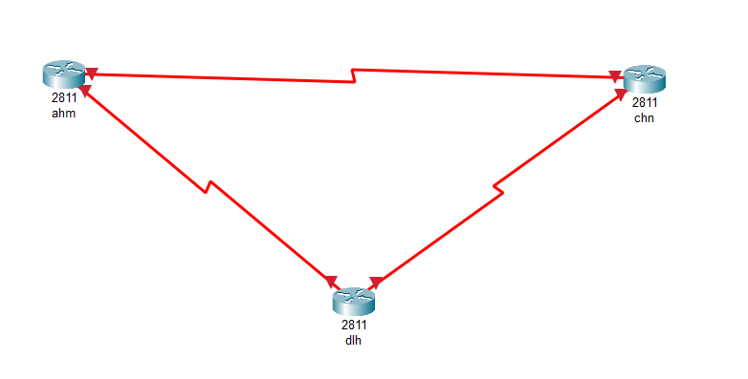
- Select 2950T-24 Switches to connect to routers for each sub branch and connect equivalent PCs to each switch
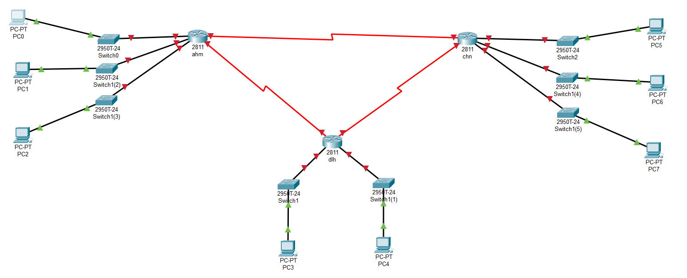
- Now we will interface the serial ports in each router and provide clock rate
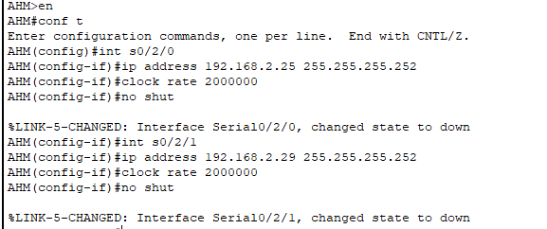
- Repeat the process for all routers and the serial port’s state will be up
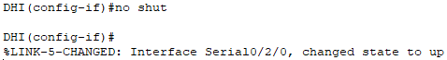
- Now we will interface the fastethernet ports in each router
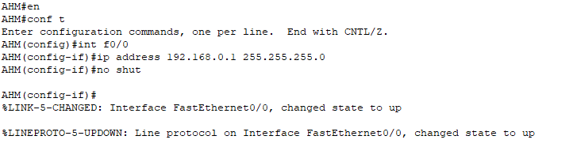
- Repeat the process for all sub branches of all other routers
- The resulting network should look like this:

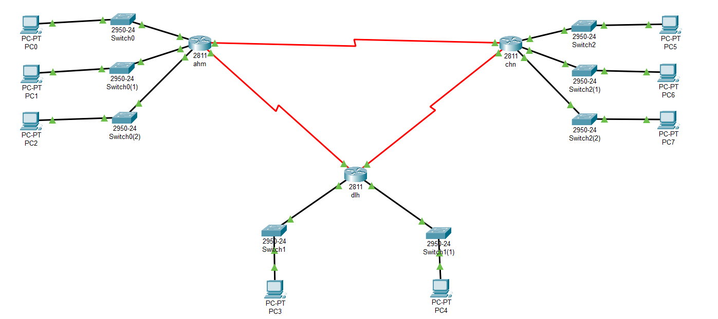
- Conclusion: The experiment demonstrates the design of IPv4 addressing with minimum wastage of IP addresses using VLSM and Subnetting

