Experiment 9B
AIM:
To study and configure IOT registration server with wireless network.

Objective:
To create a wireless network of home devices and server and configure IOT registration in the server.

Materials Required:
- A computer with an active network connection (Windows, macOS, or Linux)
- Packet tracer software application installed

Procedure, Output and Observations
- Click on end devices, go to Home tab and select motion detector and web camera and place it. Place a Home gateway by typing dlc-100 as shown
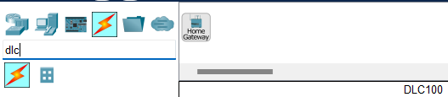
- Click on the web camera and go to physical tab and click advanced at the bottom right corner to access the I/O config tab.
- Set the network adapter to PT-IOT-NM-1W
- Click on the motion detector and go to physical tab and click advanced at the bottom right corner to access the I/O config tab.
- Set the network adapter to PT-IOT-NM-1W
- Place a tablet for monitoring.
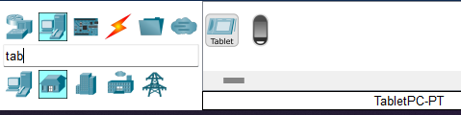
- Click on DLC-100 Home gateway, go to config tab and select wireless. Change the SSID of choice EX:MyHomegateway
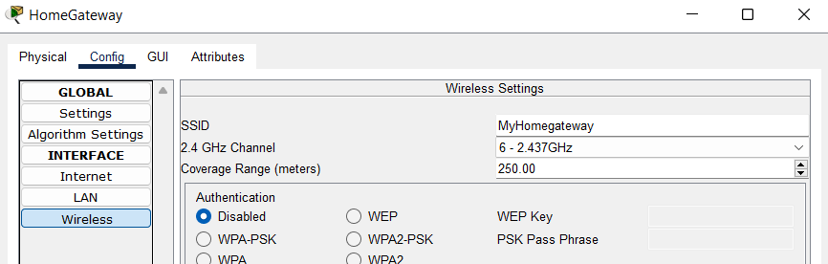
- Now to configure the IOT devices, Click on Webcamera go to config tab, in Wireless section, change the SSID to MyHomegateway.
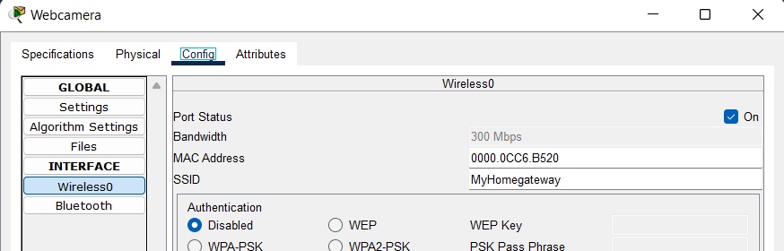
- Click on Motion detector, go to config tab, in Wireless section, change the SSID to MyHomegateway.
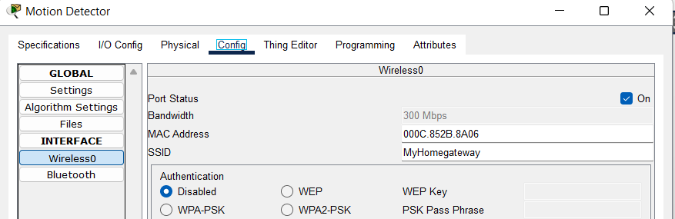
- Click on Tablet, go to config tab, in Wireless section, change the SSID to MyHomegateway.
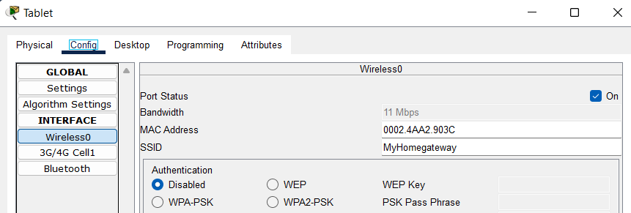
- The network should be wirelessly connected as shown
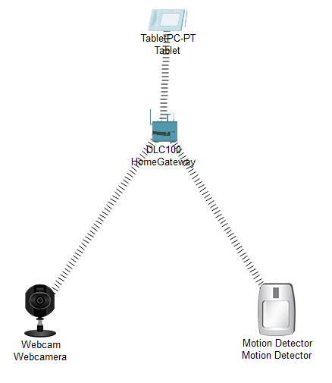
- Click on web camera go to config , go to wireless and in IOT server click on Home gateway. Click on Motion detector go to config , go to wireless and in IOT server click on Home gateway.
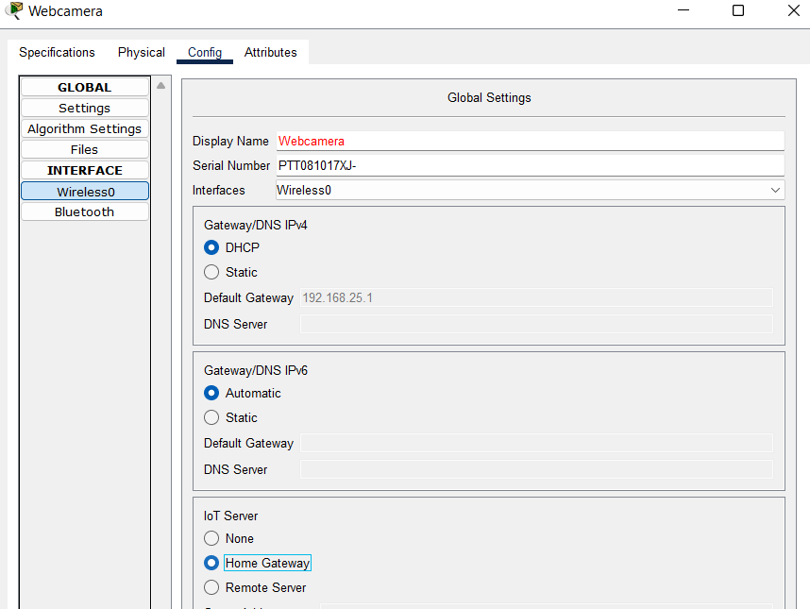
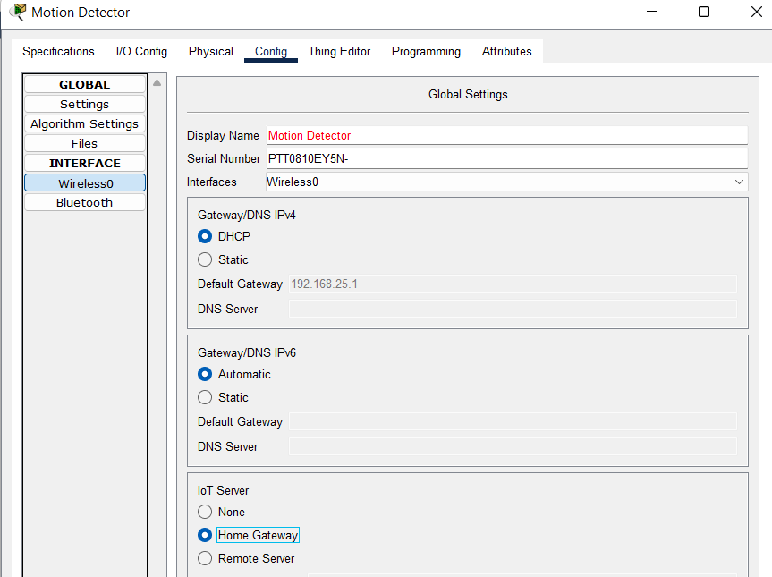
- Now go to desktop tab in tablet and click on IOT monitor
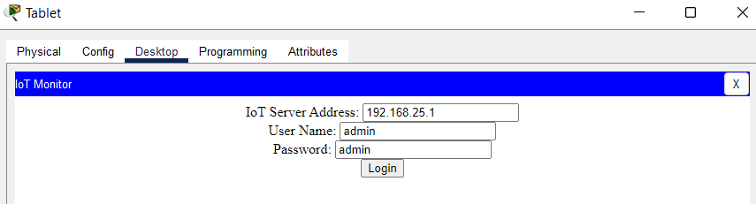
- It will auto assign the server IP, name and password. Click on login.
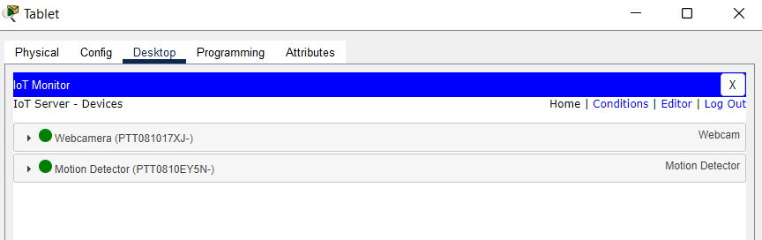
- Now to add conditions to the devices, click on conditions, click on add to add rule.
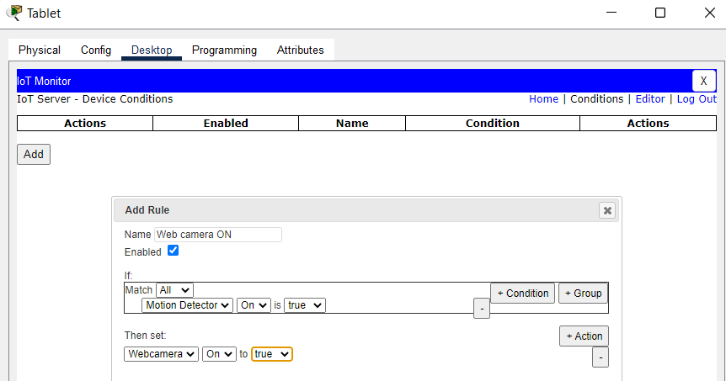
- Now to add off condition:
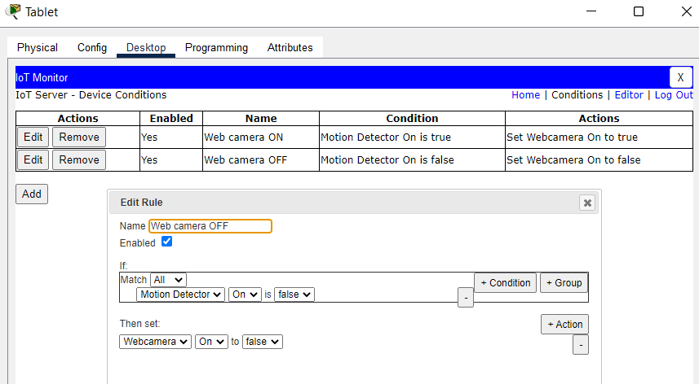
- Now to test it, hover the mouse pointer over to motion sensor while pressing alt key.
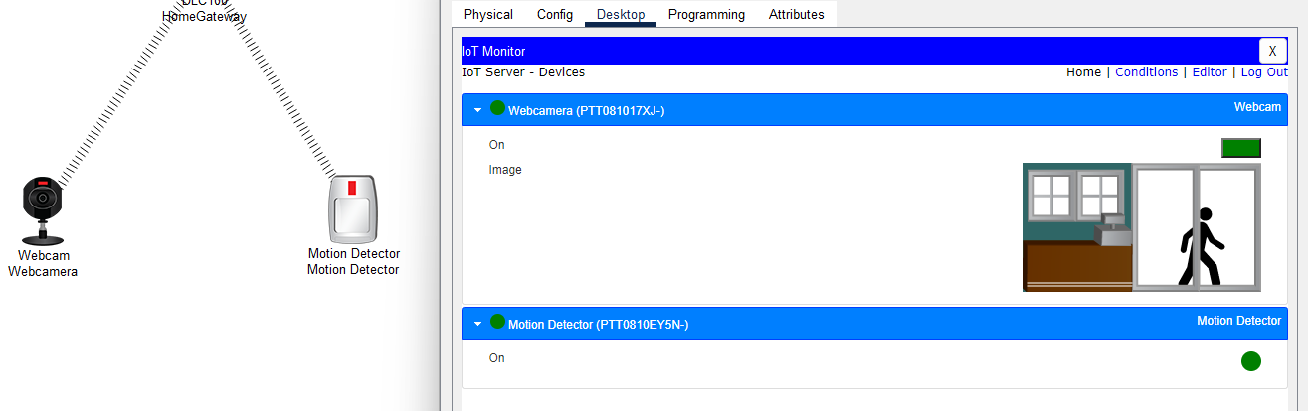
- Conclusion: The experiment demonstrates the use of Wireless IOT registration server and its services for detecting motion and capturing it in web camera.

